Cover sheet for submission of



work for assessment

# PROJECT PROPOSAL

**HEALTHCARE CUSTOMER RELATIONSHIP MANAGEMENT (CRM) SYSTEM**

**ESTIMATION METHOD**

1. **Sprint backlog item (from Sprint 1)**

Item name: Account login/logout feature on the patient engagement platform Brief Description

As part of the account management in the healthcare CRM system development, the above sprint backlog will integrate the functionality that allows patients to appropriately and securely log in and log out of their user accounts, the end-users of this engagement platform include patients and healthcare staff. Having a secure login mechanism is necessary to protect sensitive patient information and ensure that only authorized people can access the accounts. This prevents authorized violations of patient privacy and confidentiality.

Required tasks:

* Understand the login/logout requirements
* Design and outline the feature architecture
* Implement the login/logout feature
  + Implement the Front-end
  + Implement the Back-end
* Perform testing to ensure the login/logout feature works correctly
* Go-live the feature
* Write the instructions and make technical documentation for the feature

In the next part, each required tasks are split into several smaller sub-tasks to visualize the development process of the login/logout feature more clearly. For each sub-task, the estimated time to complete and the personnel responsible for the task are also included.

# Work Breakdown Structure (WBS)

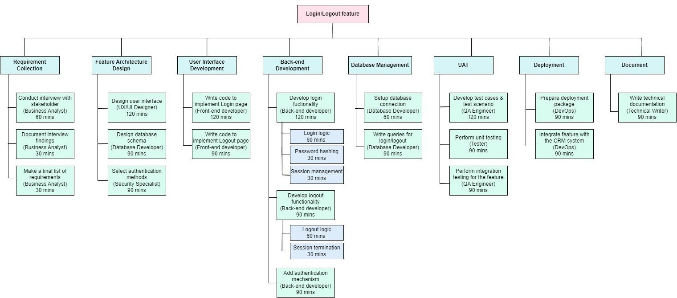



*Figure 1: Work Breakdown Structure of Login/Logout feature*

**RATIONALE**

The WBS provided above takes an activity-based approach rather than a product-based approach. Its focus is on the specific tasks involved in developing the login/logout feature, rather than the final product itself. It is evident that the desired outcome of this development item is a feature enabling end-users to securely and correctly login/logout of their accounts. With an activity-based WBS, each task is clearly defined and assigned to specific members of the development team. This approach promotes effective time management as it allows for easier tracking of task progress compared to tracking the progress of building a product as a whole. The product-based approach may be more suitable for the WBS of a larger product that can be divided into sub-products. However, for the login/logout feature, which serves as a component of the CRM system, it is more appropriate to treat it as a sub-product of the CRM system itself. Therefore, its development and management should be approached through sub-tasks rather than smaller sub-products.

The WBS is designed based on 7 stages of the Software Development Lifecycle (SDLC). The detail of how 8 modules in the WBS aligned with the SDLC is listed as follows:

|  |  |
| --- | --- |
| **Software Development Lifecycle** | **Work Breakdown Structure** |
| Planning & Analysis | Requirement Collection |
| Design | Feature Architecture Design |
| Implementation | User Interface Development Back-end development Database Management |
| Testing & Integration | UAT  Deployment |
| Maintenance | The WBS only focused on the development process, so the maintenance phase is not mentioned.  However, the Documentation module can provide useful materials for further maintenance |

*Table 1: How WBS aligned with the SDLC*

According to the WBS, all tasks that require 120 minutes to complete can be considered crucial in the development process as they represent core functionalities necessary for the login/logout feature to function at its most basic level. For example, both the user interface design and implementation are allocated 120 minutes each because the user interface serves as a critical component in determining the effectiveness of end-user interactions. Without a well-designed interface prototype, the implementation of code for the user interface may encounter difficulties. The back-end functionality also plays a vital role in ensuring the secure and safe processing of user account login/logout actions. Therefore, it is essential to construct the back-end functionality, with 120 minutes for the login and 90 minutes for the logout. The difference in time allocation between login and logout can be explained by the complexity of handling the login process, which tends to be more complicated than the logout process.

The other 90-minute tasks outlined in the WBS are also important for the proper operation of the login/logout feature, but their complexity level is lower than the 120-minute tasks. For example, two tasks related to the database: designing the database schema and writing queries for login/logout, are estimated to be completed within 90 minutes. While these tasks are essential for enabling the feature to function correctly and ensuring that data is stored in an organized manner based on a schema, they are easier to handle compared to the code implementation. On the other hand, the task of selecting an authentication mechanism within 90 minutes is feasible, but it is crucial to dedicate sufficient time to achieve an acceptable security level as healthcare is a sensitive domain. It is necessary to spend time comparing different authentication options to select a mechanism that aligns with the clients' requirements and regulatory compliance standards.

In the UAT (User Acceptance Testing) module, the task of preparing test cases requires more time compared to other tasks. This is because it involves critical thinking to identify and outline all potential scenarios that could potentially cause issues in the feature. On the other hand, the task of performing testing requires less time and effort. This is because it involves executing the test cases

that were designed in the previous task. Since the test cases have already been defined, less significant issues may occur during this phase.

Regarding the documentation tasks, summarizing interview findings is easier and quicker compared to preparing technical documents related to the feature. An interview often lasts for 30 minutes to 1 hour, while technical documents need to cover the entire development process and provide comprehensive details, which can be a more time-consuming and involved task.

In the Deployment module, it is estimated that both tasks can be completed within 90 minutes. Since the login/logout feature is just a component of the larger CRM project, the time needed to prepare the deployment package and integrate the feature into the main system is quite short. However, as this is the final stage before releasing the feature, I decided to extend the estimated time for these tasks. This extension allows better preparation to ensure that the deployment process is well-executed and that the feature is integrated correctly into the main system,